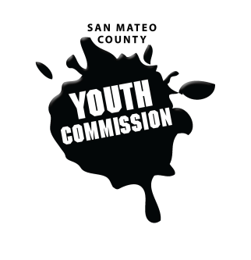
San Mateo County Youth Commission

Room 100

225 37th Ave.
San Mateo, CA 94403

September 15, 2016

6:15-8:15 PM

Workgroup Meeting

- Call to Order 1 min

- Public Comment 10 min
Members of the public may address the commission on youth related issues and concerns that are not currently on the agenda. Please complete a Request Form found in the front entry, hand it to one of the Youth Commission Chairs, and limit your remarks to two minutes. The public is welcome to speak on Agenda Items throughout the meeting.

- Approve Agenda 1 min

- Introductions & Icebreakers 10 min
Short introductions
All My Neighbors

- Review Group Agreements 5 min

- Brown Act Training, Conflicts of Interests, Boards & Commission 35 min
David Silberman – County Counsel
LGBTQ Commission Guests

- BREAK 5 min

- Boards & Commissions Introductions & Overview 15 min
Explanation of past boards and commissions served on and other opportunities

- Openings on Committees and Secretary Position 10 min
Announce any openings on committees and discuss Secretary position responsibilities

- Future Logistics 10 min
Carpooling, Planning Committee, Attendance Policy Review/Changes, Dress Code Review, Agenda Setting

- Executive Board – Committee Assignments 15 min
Executive Board will allocate open positions on committees

- Adjournment 1 min

Next Workgroup Meeting: October 20, 2016
Next Public Meeting: September 22, 2016

