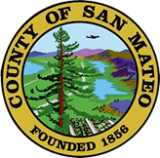
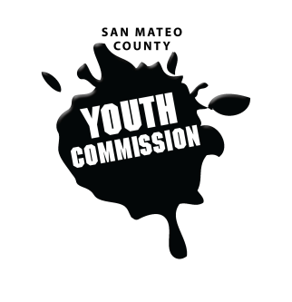
San Mateo County Youth Commission

Room 100

225 37th Ave.
San Mateo, CA 94403

September 8, 2016

6:15-8:15 PM

- Call to Order 1 min

- Public Comment 10 min
Members of the public may address the commission on youth related issues and concerns that are not currently on the agenda. Please complete a Request Form found in the front entry, hand it to one of the Youth Commission Chairs, and limit your remarks to two minutes. The public is welcome to speak on Agenda Items throughout the meeting.

- Approve Agenda
- Introductions & Icebreakers 5 min
“Speed Dating” get-to-know-you

- Attendance policy review 10 min
Potential change to bylaw?

- Upcoming meeting agendas/content/locations 25 min
9/8
1. Intros and Icebreakers
2. Group agreements & Norms
3. Overview of YC - Exec Committee
4. Rules of Order and example of how to run a meeting by Youth Commissioners

9/15
1. Welcoming
2. Mission Statement
3. Priorities
4. The Brown Act, Conflicts of Interests, and Boards and Commission Rules - County Counsel - County Council (~45 mins)
5. Board, commissions, committees intros done by commissioners
6. Announcing openings in committee positions

9/22
1. Swearing in
2. Selecting committee allocations for new commissioners
3. Voting on committee positions
4. Adopting mission/goals for the year
5. Other business?

- BREAK 10 min

- Upcoming speakers/presentations 20 min
Potential topics: LGBTQ topics, Leadership, Cross-cultural Communication, *Policy Analysis/Advocacy, Social Media, Inequity vs equity, Meeting Facilitation and Agendas, *Adolescent Report Findings and Recommendations, Professional networking, Marketing the YC to others - elevator pitch, Districts/borders

- New website content 20 min
Target audience: youth, parents, the public, potential partners
Site contents:
- Upcoming meeting locations, agenda's, dates and times
- Meeting minutes
- Current Youth Commission members and short bios
- Adolescent Report (can link to www.gethealthysmc.org website)
- Contact information for staff
- Workgroup or committee's and their projects for the year
- Timeline for recruitment and where to find the application
- Opportunities to partner with the Youth Commission
- Events- Youth Summit, committee projects, etc.

- Adjournment 1 min

Next Workgroup Meeting September 15, 2016
Next Public Meeting: September 22, 2016

