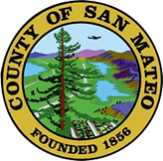
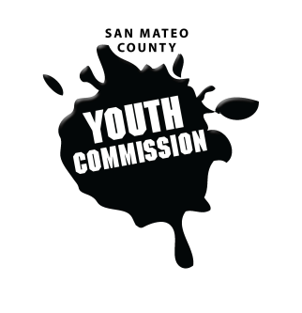
San Mateo County Youth Commission

420 Purisima Way
Half Moon Bay, CA 94019

August 12, 2017

10:00 AM – 5:00 PM

Group Agreements

- Be Respectful
- One Mic - Pay attention to speaker
- Step up, step back – allow others the chance to speak
- Be respectful with cellphone use
- Share responsibility and workload
- Come to meetings and be on time
- Cooperate, compromise, collaborate
- Communicate
- Be committed - come up with a plan and stick to it
- Be engaged & participate

Retreat Meeting

- Public Comment
Members of the public may address the commission on youth related issues and concerns that are not currently on the agenda. Please complete a Request Form found in the front entry, hand it to one of the Youth Commission Chairs, and limit your remarks to two minutes. The public is welcome to speak on Agenda Items throughout the meeting.

- Introductions – Adam

Name, pronouns, grade, school, fact

- Group Agreements – Rubi and Montze

- Overview of San Mateo County Structure – Clara & Adam

- Overview of the Youth Commission - Clara

Structure, partnerships, leadership, history, procedural rules, terminology

- Snack and Energizer - Sarah

- Committee Brainstorming

- Lunch

- Equity, Diversity, and Cultural Humility - Shireen

- Snacks and Team Building – Annie, Liza, Sarah, Faith

- Affirmation Activity – Jack and Eeshan

- Updates

- Announcements

- Closing

- Adjournment
Next Workgroup Meeting: September 14, 2017
Next Public Meeting: August 31, 2017

