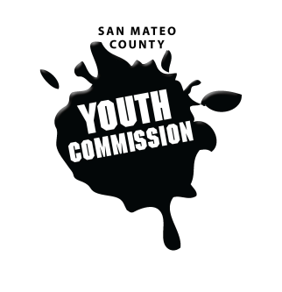
San Mateo County Youth Commission

Board of Supervisors Chambers
400 County Center
Redwood City, CA 94063

May 25, 2017

5:45-8:15 PM

Group Agreements

- Be Respectful
- One Mic - Pay attention to speaker
- Step up, step back – allow others the chance to speak
- Be respectful with cellphone use
- Share responsibility and workload
- Come to meetings and be on time
- Cooperate, compromise, collaborate
- Communicate
- Be committed - come up with a plan and stick to it
- Be engaged & participate

SPECIAL Meeting

- Call to Order

- Roll Call

- Public Comment
Members of the public may address the commission on youth related issues and concerns that are not currently on the agenda. Please complete a Request Form found in the front entry, hand it to one of the Youth Commission Chairs, and limit your remarks to two minutes. The public is welcome to speak on Agenda Items throughout the meeting.

- Approve Agenda

- Approve Minutes

- Remarks by Commissioners

- Recognition of Seniors

- Immigrant Youth Award

- Committee Presentations

- Commission Liaison Presentations

- BREAK

- Legislative Committee Letter Vote

- Adolescent Needs Committee Letter Vote

- Transition Committee Established

- Chair & Vice Chair Vote

- Peer Evaluations

- Updates

- Announcements

- Adjournment

