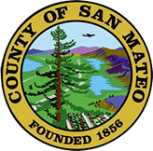
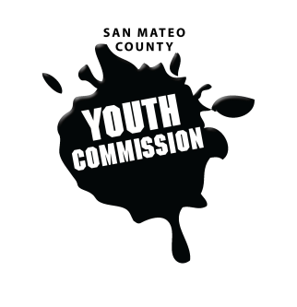
San Mateo County Youth Commission

1670 S Amphlett Blvd, Suite 250
San Mateo, CA 94402

Join online at:
https://zoom.us/j/804406506

March 8, 2018

5:30-7:30 PM

Executive Board Meeting

- Call to order

- Roll call

- Public comment
Members of the public may address the commission on youth related issues and concerns that are not currently on the agenda. Please complete a Request Form found in the front entry, hand it to one of the Youth Commission Chairs, and limit your remarks to two minutes. The public is welcome to speak on Agenda Items throughout the meeting.

- Approve agenda

- Check-in

- March meeting planning

- Revisit SMCYC structural changes discussion

- Committee updates on committee projects & events

- Updates
Chairs, Staff, Commission liaisons

- Announcements

- Adjournment

Next Executive Board Meeting: April 5, 2018
Next Workgroup Meeting: March 15, 2018
Next Public Meeting: March 22, 2018

