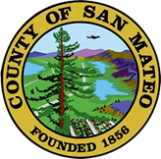
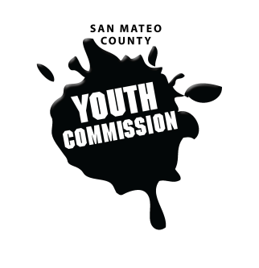
San Mateo County Youth Commission

Diamond Room

225 37th Ave.
San Mateo, CA 94403

March 2, 2017

6:15-8:15 PM

Executive Board Meeting

- Call to Order

- Roll Call

- Public Comment
Members of the public may address the commission on youth related issues and concerns that are not currently on the agenda. Please complete a Request Form found in the front entry, hand it to one of the Youth Commission Chairs, and limit your remarks to two minutes. The public is welcome to speak on Agenda Items throughout the meeting.

- Approve Agenda

- Approve Minutes

- Check-in/Icebreaker

- Plan for March meetings
Marijuana Presentation
Dr. Morrow
Boards and Commissions Chairs

- Youth Conference Assignments
Pitch budget allocations/spending
Snapchat filter, shirts, etc

- Review changes to bylaw

- Feedback & Recommendation of Reappointment Form

- Announcements

- Adjournment

