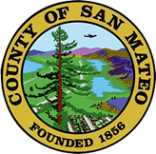
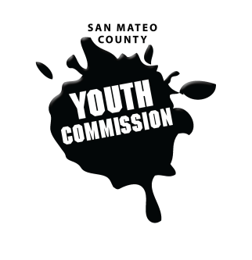
San Mateo County Youth Commission

1670 S Amphlett Blvd, Suite 205
San Mateo, CA 94402

Join online at:

https://hangouts.google.com/hangouts/_/yli.org/smcycexecutiveboard

October 13, 2017

5:30-7 PM

Executive Board Meeting

- Call to order – 5:36

- Roll call – Annie, Faith, Jack, Sophia, Eeshan

- Public comment - None
Members of the public may address the commission on youth related issues and concerns that are not currently on the agenda. Please complete a Request Form found in the front entry, hand it to one of the Youth Commission Chairs, and limit your remarks to two minutes. The public is welcome to speak on Agenda Items throughout the meeting.

- Approve agenda - motion to approve – Sophia, Jack - second

- Check-in/Icebreaker – How are the fires affecting you?

- Discuss visioning from public meeting - create commission vision

- Organize trainings/presentation schedule for 2017-2018

- Set agendas for October

- Discuss opportunities for collaboration
FNL, town halls, BHRS

- Updates
Committees, Chairs, Staff, Commissions

- Announcements

- Adjournment

Next Workgroup Meeting: October 19, 2017
Next Public Meeting: October 26, 2017

